**REP Los Angeles**

**1. Vision Statement / Mission:**

Our food application will show you all the street food vendors closest to you! It will focus on elusive vendors that sell Raspados, Elotes and Paletas. Eventually, we would like to expand to other street vendors such as taco stands, hot dog carts and other specialty food stands

There will be separate accounts for vendors and for customers. There is one mobile application where both the user and vendor can log onto. It will default as a user login, but allow for vendor sign in on the same page.

Users will have a map view of their location with the nearest vendors. In map view, each vendor will show up as an icon indicating their vendor type (food trucks will have a truck icon, food stands will have a food stand icon, etc.).

**Functionalities:**

* Consumer Application
  + Create/Edit/Delete Consumer Account
  + View closest food vendors (geo-tracker)
  + Filter/Sort vendors by different categories
  + Post photos (scan for inappropriate images, prevent posting if necessary)
* Vendor Application
  + Create/Edit/Delete Vendor Account
  + Must be able to check legitimacy of vendor
  + Set schedule (Fixed or Live)
  + Set up location

**Functional Requirements:**

* Create Accounts
* Location Mapping
* Update Information (Vendor and Customer)
* Filter by Distance, and/or Type
* Go Live or Set Schedule (Vendors)

**Non-Functional Requirements:**

* Database
* Implement location mapping
* Security (Validate Vendors)
* Check for existing accounts
* Intuitive UI design

**2. Roadmap:**

Development Languages: Javascript, JSX

Deployment Environment: iOS, Android

Deployment Characteristics:

**3. Development Methodologies:**

**User Cases:**

|  |  |  |
| --- | --- | --- |
| Use Case ID | Name | Description |
| 001 | Start Page | Customer opens app and leads to login page |
| 002 | Login | Customer logs in and leads to users home page |
| 003 | Map | Customer’s map displays all registered and active vendors near-by |
| 004 | Filter | Customer can filter near by vendors by categories |
| 007 | New User | Customer clicks create account and takes them to new user page |
| 008 | Social Media | Vendors can link their social media account on their bio. |
| 009 | Photos | Customer can post photos to vendor’s page |
|  |  |  |
| 011 | Favorites | Customer’s can add vendors to favorites list |
| 012 |  |  |
| 013 | New Vendor | Vendor clicks New Vendor and is redirected to sign up page |
| 014 | Schedule | Vendor can set up business hours and appear active to customers |
| 015 | Live | Vendors can go live and appear on customer’s maps or go offline and disappear on customer’s maps |
| 018 | Pins | Vendors show up with different icons depending if they have carts, stands, or trucks. |

**4. Development Tools:**

* Framework: React Native
* Languages: Javascript
* Code Editor: Visual Studio Code
* Backend Language: Fire Base
* GUI Builder: Code from scratch
* Server:
* Libraries: <https://codingislove.com/top-15-react-native-libraries/>

**5. Estimated Scope:**

**\*Non-**Highlighted functions will be completed this semester

|  |  |  |  |
| --- | --- | --- | --- |
|  |  | **Schedule** |  |
| **Use Case ID** | **Name** | **Description** | **Sprint** |
| 001 | Start Page | Customer opens app and leads to login page | 2 |
| 002 | Login | Customer logs in and leads to users home page | 4 |
| 003 | Map | Customer’s map displays all registered and active vendors near-by | 6 |
| 004 | Filter | Customer can filter near by vendors by categories | 7 |
| 007 | New User | Customer clicks create account and takes them to new user page | 4 |
| 008 | Social Media | Customer can sign in with social media | 3 |
| 011 | Favorites | Customer’s can add vendors to favorites list | 12 |
| 013 | New Vendor | Vendor clicks New Vendor and is redirected to sign up page | 3 |
| 014 | Schedule | Vendor can set up business hours and appear active to customers | 5 |
| 015 | Live | Vendors can go live and appear on customer’s maps or go offline and disappear on customer’s maps | 5 |
| 018 | Pins | Vendors show up with different icons depending if they have carts, stands, or trucks. | 9 |

|  |  |  |
| --- | --- | --- |
| **Constraint ID** | **Name** | **Description** |
| CON0001 | Language | Javascript |
| CON0002 | Code Editor | VSCode |
| CON0003 | Framework | React Native |
| CON0004 | Database | SQL |
| CON0005 | Libraries | [https://codingislove.com/top-15-react-native-libraries](https://codingislove.com/top-15-react-native-libraries/) |

**6. Estimated Size:**

|  |  |  |  |
| --- | --- | --- | --- |
| **Total SLOC** | **Name** | **Source Lines Of Code (SLOC)** | **Produced SLOC** |
| 300 | Start Page/Login | 300 | 276 |
| 550 | Home | 250 | 160 |
| 1050 | Map | 500 | 143 |
| 1350 | Filter | 300 |  |
|  |  |  |  |
|  |  |  |  |
| 2150 | New User | 200 | 164 |
| 2250 | Social Media | 100 |  |
| 2350 | Photos | 100 |  |
| 2550 | Report Photos/ Reviews | 200 |  |
| 2750 | Favorites | 200 |  |
|  |  |  |  |
| 3450 | New Vendor | 500 | 194 |
| 3950 | Schedule | 500 |  |
| 4050 | Live | 100 | 58 |
|  |  |  |  |
|  |  |  |  |
| 6050 | Pins | 300 |  |

Estimated size for the “REP APP” release v1.0.0 is roughly 3,800 lines of codes.

**7. Identifications of Preliminary Risks:**

|  |  |  |  |  |
| --- | --- | --- | --- | --- |
|  | **Risk** | **Impact** | **Decrease Probability** | **Status** |
| 001 | Team member does not meet deadlines/quits  (schedule change) | schedule delay, re-assign responsibilities, each team member would have more responsibilities | Maintain constant communication with regards to updates or changes. Address problems early. | N/A |
| 002 | similar app coming out with better features | App release may not be as successful/ fewer users. | Remain up-to-date on any applications similar to the one being designed, include better features. | N/A |
| 003 | IT Troubleshooting hardware/software | schedule delay. frustration within team, stress. | Work as a team to identify a quickly find a solution to hardware/software problems | **“**completed” |
| 004 | Team inexperienced with required tools | full features may not be taken advantage of. progress delay.  implementing functionalities becomes more difficult. | Each team member should help/educate others on how to use the tools required for the project before any coding is done.  Schedule could be modified to meet deadlines. | **“**in progress” |
| 005 | Developing wrong functionalities | loss of time. code must be re-written. Application release date gets delayed. | communicate with each team member to make sure that the correct functionalities are being implemented | N/A |
| 006 | Loss of Data | Most if not all Progress with project is lost. less time to complete project/failure to release project on schedule. | save all data in a cloud or in a portable storage device. | N/A |
| 007 | bugs during integration/ runtime (different phone versions) | take time to identify application compatibility with different phone versions. identify coding errors.schedule delay | finish tasks on time according to the schedule. Include extra within the schedule time to fix bugs | “in progress” |
| 008 | difficulty fixing errors | team members focus on fixing errors rather than completed tasks and functionalities. | Understand code, explain what is going on to each team member. | “in progress” |
| 009 | changing requirements | More work is created, tight schedule , new requirements may be incompatible/inconsistent with current functionalities. | analyze and make sure that every requirement is necessary and makes sense. | N/A |
| 010 | not enough features | Must include more features, make sure features are compatible, design must be modified to fit new features. | include extra features only if project is complete or nearly finished. | N/A |
| 011 | incorrect design | Design may be inconsistent with functionalities. plan new design. Schedule delay. | design should be discussed with all members. Team should agree on a particular design. Design should meet user requirements and functionalities. | N/A |
| 012 | Not enough resources, Resources too expensive | team is unable to finish tasks. | resources to be used must be planned out before building the project. members should maintain realistic expectations for resources. | “in progress” |
| 013 | Change of tools for design | Team must be re-educated to work with the new tools. Time is lost. Schedule delay. | The tools being used must be able to execute all of the functionalities that will be used within the program. Any new/extra tools being used must be compatible with current tools. | N/A |

**8. Description of the Project Asset Library (PAL)**

* Using github for code sharing and version control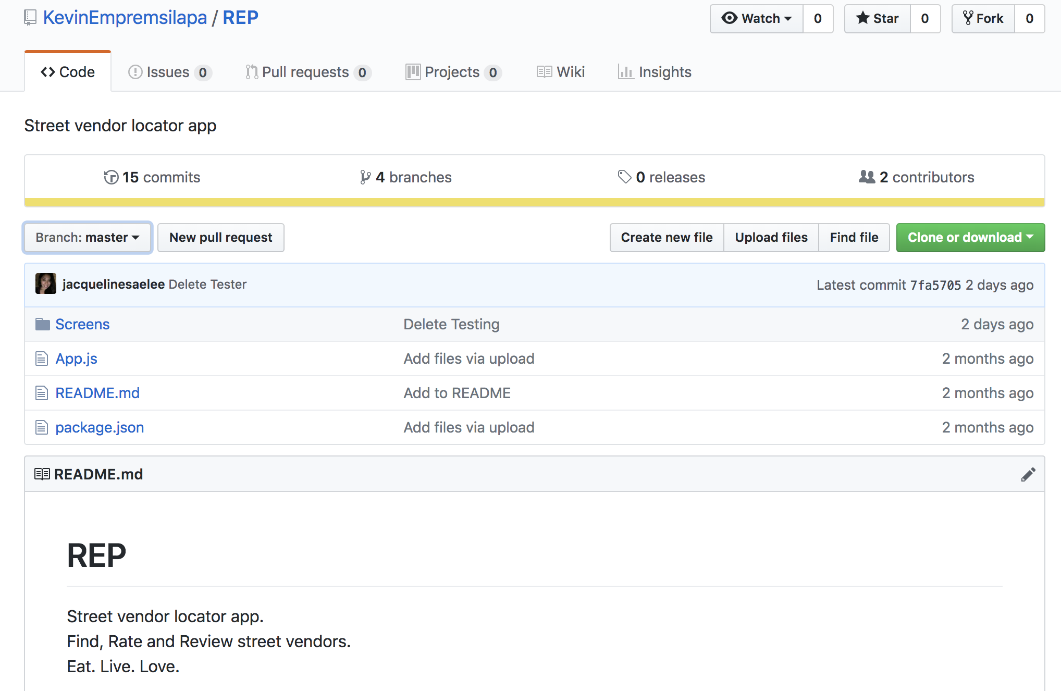
* Using google docs for sharing word documents among team members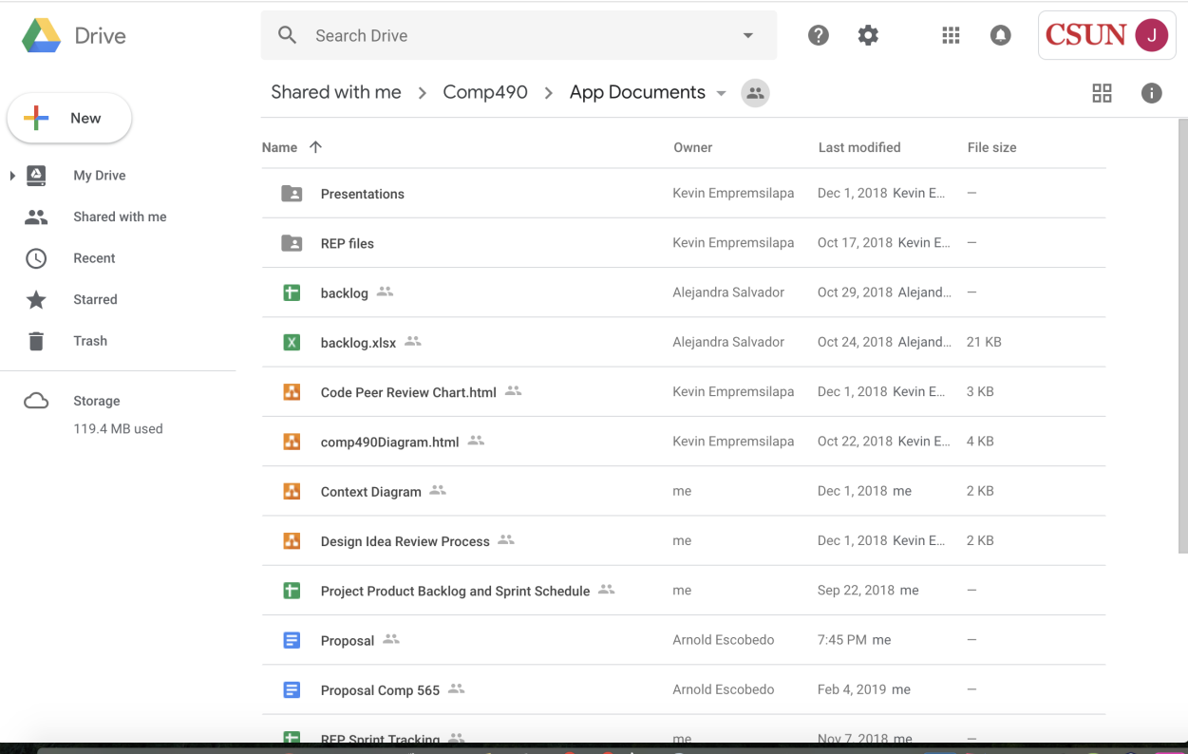

**9. Description of how project progress will be tracked both at the project and sprint level i.e. Management tool (s) name (e.g. MIT Spreadsheet), description, and usage.**

* Trello for documenting sprints and burndown charts

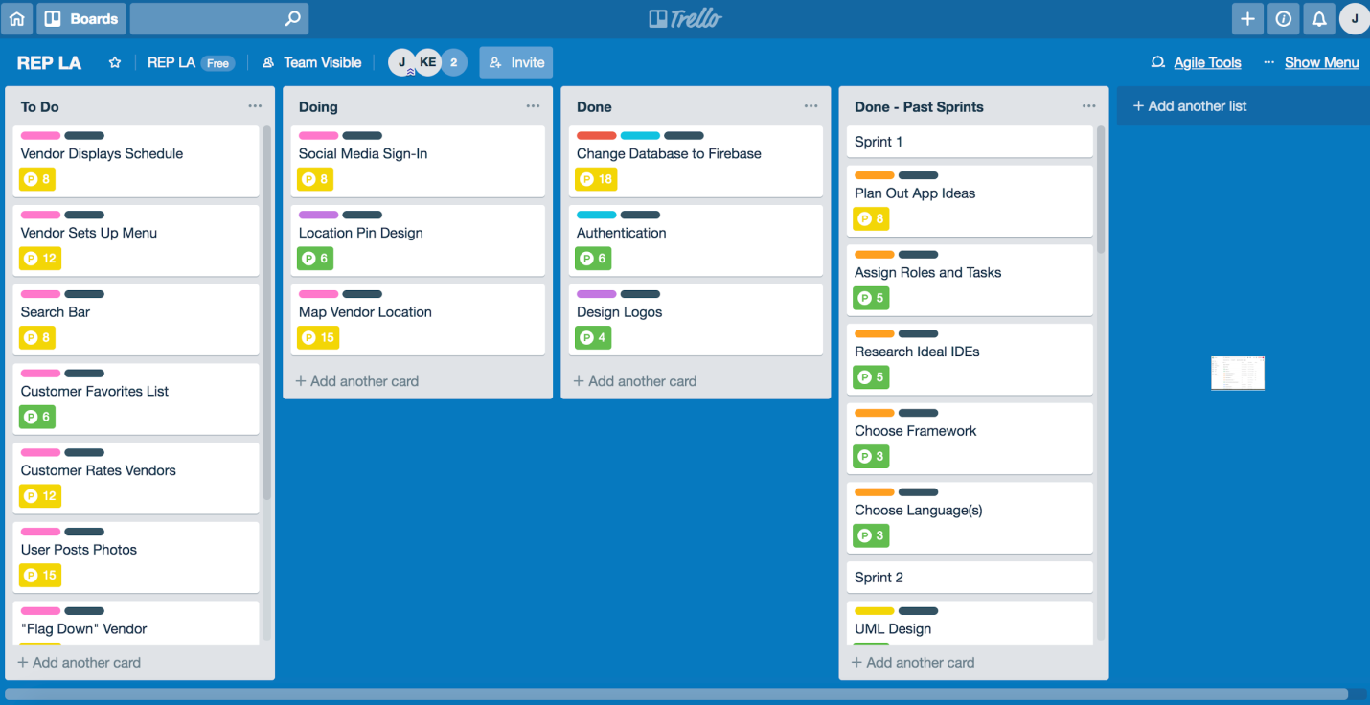

**10. Project development process description--do not describe generic Scrum, but specifically how your team will execute this project e.g. team organization/roles, what/when planning will be done, description of managing the product backlog, releases, sprints, and retrospectives (reviews), artifacts/documentation prepared, etc. (This section can be brief for this first iteration – you will add more later.)**

* team roles
  + FrontEnd
    - Kevin Empremsilapa
    - Jacqueline Saelee
  + BackEnd
    - Arnold Escobedo
    - Alejandra Salvador
* when planning will be done
  + planning will be done during the first two sprints
* description of managing product backlog, sprints and releases.
  + product backlog and sprints would be managed using Trello.
  + releases will be controlled over github.
* Peer Review
  + Deliverables are placed under 1 of 4 columns based on their status
    - Ideas, Under Review, Approved, Denied
  + Status of deliverables is determined during team meetings

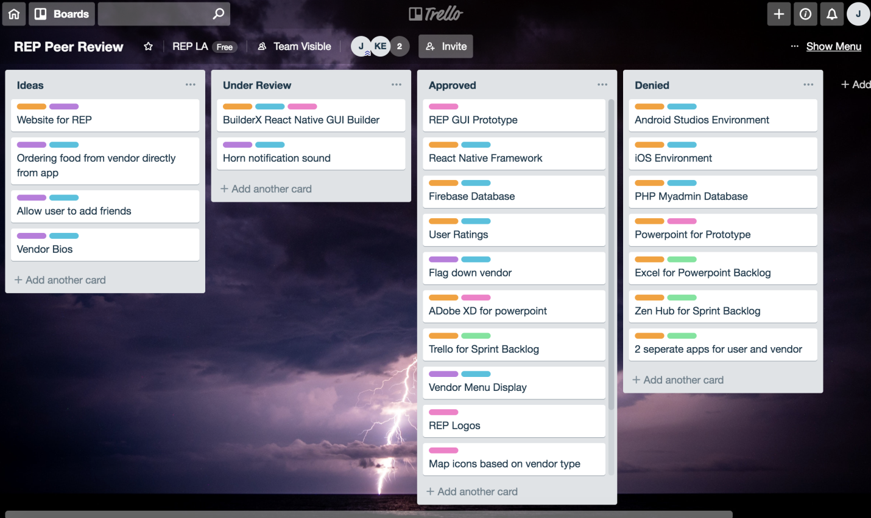

**11. Changes made in Spring 2019**

* No longer utilizing BuilderX for GUI due to financial and software glitch reasons
* GUI will be created from scratch using JavaScript, as well as the use of open-source libraries
* Functionalities removed due to time consumption creating the GUI without BuilderX
  + Vendor menu setup
  + “Flag” a vendor
  + Vendor reviews
  + Customers and Vendors posting photos
  + Food ratings
  + Credit card purchase and authentication